Amazing Books

Name: Zack Davidson

Student Number: 30008095

Class Name: HND Application Development

Class ID: D76N34

Contents

Requirements Specifications 3

Functional Requirements 3

Non-functional Requirements 3

Use Case Diagram 4

ERD Diagram 5

Physical Copy 6

# Requirements Specifications

I have been asked to get a list of all the functional requirements and non-functional requirements. Here is a list of both requirements determined

## Functional Requirements

* Search Inventory
* Track Sales & Display sales
* Insert, Delete and update items
* Track Customer Information
* Place and view customer orders

## Non-functional Requirements

* Deadline 17th Dec 2015
* Budget £20,000
* Data should be normalised to 3rd form
* Validation using macros, switchboards or appropriate application language
* Users can vary to keep keystrokes to a minimum

Date: ______________________________

Please sign the appropriate signature placement



# Use Case Diagram

Using the above information I had to create a simple use case diagram.

I came up with the following:



In the Scenario it stated that the manager is the only person whom can edit and delete items for the inventory. This left the admin assistant inapplicable to do these two behaviours.

## ERD Diagram

I have created an ERD Diagram that the database can be based off

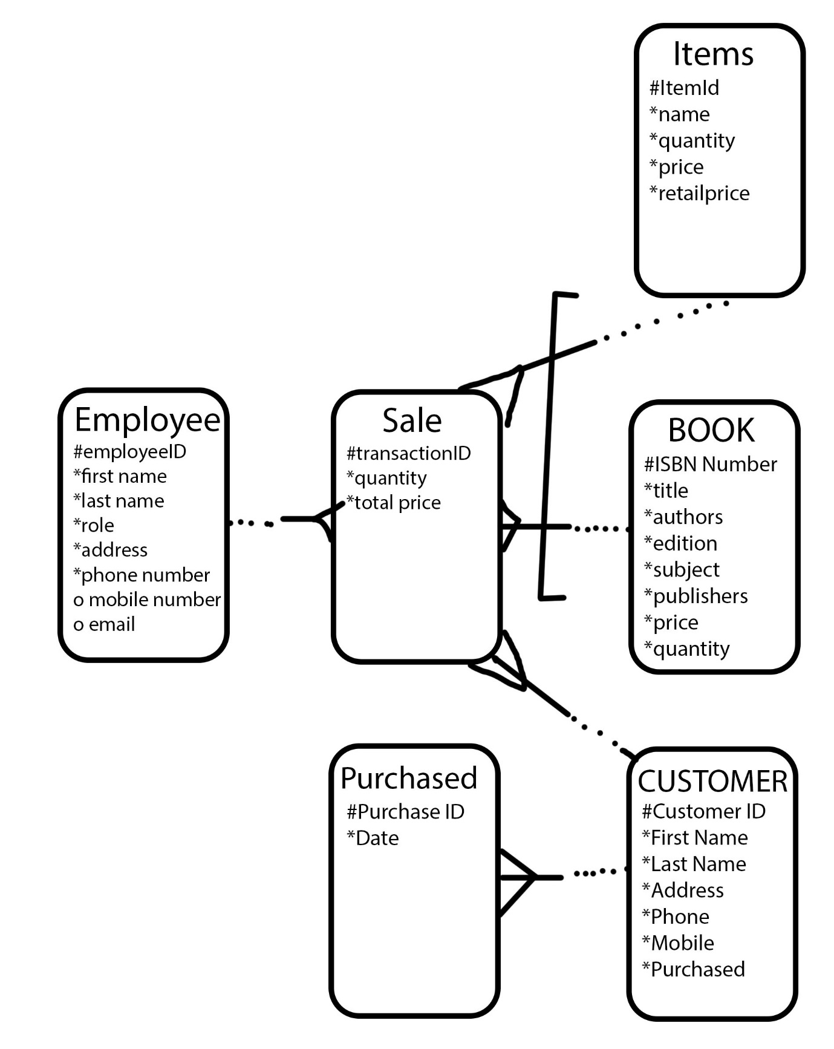

## Physical Copy

I have been asked to make a physical copy of the table. This physical copy of the table will be the main source of creating the actual database. This will lead me in the right direction.

